Business Day

Giant clay vessels give wine freedom to shine
15 MARCH 2018 - 05:30 JANINE STEPHEN
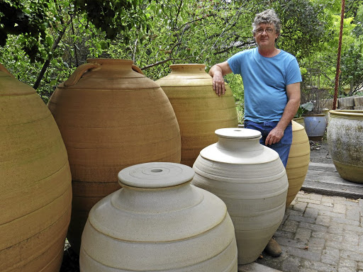
More than a tipple: Potter Yogi de Beer with the large amphoras he creates. Although stoneware is not a new wave in wine making, there is growing demand for the clay vessels. Picture: SUPPLIED
There’s nothing slight about Yogi de Beer’s amphoras. Each giant stoneware vessel requires 250kg of clay, takes weeks to shape and is fired in a kiln the size of a small garage. They are in big demand from wine makers.
De Beer crafts his vessels by hand in his pottery studio in Hout Bay, Cape Town, aptly situated in an old winery. His stoneware can breathe, allowing for the micro-oxygenation that barrels impart, but without any flavour seeping into the wine.
They’re not "classic Grecian or Roman-style amphorae with the pointy bottoms", he says. "Just my take on them: a large bottle essentially. And it’s important to me to make a decent-looking pot."
Justin van Wyk of Constantia Glen, a recent convert to maturing wine in neutral stoneware, says the vessels are big. The Bordeaux-style winery’s 2017 Constantia Glen Two blend includes a 5% "dash" of Sémillon aged in a 600l amphora.
Although the small quantity of clay-matured wine is not really discernible in the 68% Savignon Blanc, 32% Sémillon blend, Van Wyk has complimented the "texture and mouthfeel" of the wine the stoneware produced. The 2018 rendition, Van Wyk says, will contain 10% of amphora-matured wine.
Stoneware isn’t a new wave in wine making. Amphoras date back to Greek and Roman times and Georgian qvevri originated about 8,000 years ago. Traditionally, vessels were made of more porous terracotta and sealed with beeswax.
De Beer started making "wine jars" about nine years ago, after being approached by Duncan Savage, then at Cape Point Vineyards, who started experimenting in about 2006.
"The idea was to move away from an oak barrel, which heavily influences the flavour of the wines," Savage says. "We spend a lot of time fine-tuning vineyards in an attempt to showcase the terroir and variety, one doesn’t always need the taste of a tree in France."
Savage wanted a neutral vessel to showcase the minerality of the wines of the area and he wanted to try local potters and local clay. Early attempts with earthenware (terracotta) were unsuccessful and the pots were rather small.
"That’s where we ended up with Yogi," he says. "The results were incredible and the pots are beautiful: 300l to 600l works of art. You can only imagine the skill required to throw a 600l pot on a wheel."
Stoneware requires a "change of mind set with regard to making wine", says Savage. "They are far more oxidative relative to an oak barrel; one needs to adjust style accordingly. What one loses in aromatics can be made up in texture."
De Beer’s first pots for Savage held about 200l to 250l. The ideal was to go bigger, partly because larger volumes allow for consistent quantities of a wine to be produced.
De Beer has mastered 600l amphorae. He works alone, laboriously building each vessel in 20 stages. Each stage requires a period of drying and the finished pot must dry for three weeks. They are then manoeuvred into the kiln for firing: a 24-hour ordeal that requires constant monitoring of the temperature to avoid breakage.
New amphoras take three days to cool.
De Beer can only make about 24 vessels a year.
Wine makers appreciate how clay vessels, "unmask" the wine and "expose it for what it is", says De Beer.
Italian vintner and clay fan Josko Gravner has said something similar to Prowein magazine: "Amphorae affect wine the same way that amplifiers do music … good flavours become even better, while poorer ones become poorer."
An amphora costs the equivalent of a new 600l French oak barrel, says Van Wyk, but it can last a lifetime. A barrel is used for seven to eight years.
Other South African wine makers who have tried amphoras include Eben Sadie of Sadie Family Wines, Corné Marais, Chris Alheit, Anthony Hamilton Russell of Hemel-en Aarde and Peter Allan-Finlayson of Gabrielskloof.
Producing 24 amphoras a year dovetails with current demand, says De Beer, and suits the exacting, attention-to-detail methodology of niche, high-quality wine makers. "I’m still making all the pots myself, I don’t use an assistant. I’d rather supply the smaller boutique kind of winery and have a personal relationship with them."
He will work up to an 800l or 1,000l amphora, if it fits in the kiln.
"The early years had lots of challenges but I think that Yogi has nailed the classic South African amphora," says Savage.

