Suzanne Abell

Although born in Rotterdam in 1964, Suzanne emigrated with her family to Zimbabwe when she was four.

She attended school there until the age of 16 and then they came to live in UK.

Suzanne trained as a dentist specialising in oral surgery and practised in Oxford until recently.

She came to art later in life after becoming increasingly interested in the human form and especially in yoga and its movement. Knowledge of anatomy has helped her to understand the power of muscles and the bone structure within.

Suzanne returns to Africa frequently and her deep love of the continent has prompted sculptures of some of her favourite animals, such as elephants and giraffe – usually in motion.

In 2020, Suzanne was accepted to Heatherley’s School of Fine Art in London where she is currently doing a two year diploma in figurative sculpture. She was also a finalist in the David Shepherd Wildlife Artist of the Year 2020 competition.

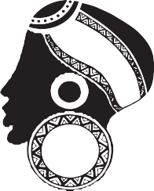
FILLINGDON
FINE A RT

